  - I2C (CCI) Controller Functional Design Specifications
Design and Implementation of CSI Controller IP
  - Version 4.0.1

  - Block Owner
  - Mohamed Zaher Fouda
Authors
Mohamed Zaher Fouda

This Page is left Blank Intentionally

Table of Contents
1 Table of Contents 1
2 Revision History 2
3 Overview 3
4 Operation and Description 3
4.1 Digital Interface 3
4.1.1 Parameters Names 3
4.1.2 Ports Names 3
4.2 Functional Description 3
4.3 Block Diagram 3
4.5 Verification Requirements 3

Revision History
Version | Date | Author(s) | Revision Notes | Owner Approval
1 | 10-2-2026 | Mohamed Zaher Fouda
3 Overview
The I2C (Inter-Integrated Circuit) Controller operates as the Camera Control Interface (CCI) within the MIPI CSI-2 subsystem. It provides a standard, two-wire, bidirectional serial bus used by the host processor to configure the camera sensor's internal registers (e.g., setting resolution, frame rate, and exposure) prior to or during image data transmission.
Configured primarily as an I2C Master, this block handles the low-level physical protocol requirements including START/STOP condition generation, Clock (SCL) generation, serial data (SDA) shifting, and ACK/NACK management. It bridges the system's parallel control bus (such as APB or a standard register interface) to the serial I2C bus, ensuring timing compliance with standard (100 kHz) and fast (400 kHz) modes.
4 Operation and Description
4.1 Digital Interface
4.1.1 Ports Names
Port Name | Port Width | Port Type | Description
Clocks & Resets
i_sys_clk | 1 | Input | System Clock used for control logic and SCL derivation.
i_rst_n | 1 | Input | Active-low Asynchronous Reset.
Upstream Interface (System / Register File)
i_cfg_req | 1 | Input | Request flag to initiate an I2C transaction.
i_cfg_rw | 1 | Input | Read/Write control (0 = Write, 1 = Read).
i_cfg_dev_addr | 7 | Input | 7-bit Target I2C Device Address (Sensor Address).
i_cfg_reg_addr | 16 | Input | 8-bit or 16-bit internal register address of the sensor.
i_cfg_wdata | 8 | Input | 8-bit parallel data to be written to the sensor.
o_cfg_rdata | 8 | Output | 8-bit parallel data read from the sensor.
o_cfg_ready | 1 | Output | Ready/Done flag indicating transaction completion.
o_cfg_error | 1 | Output | Error flag (e.g., NACK received from sensor).
Downstream Interface (I2C Bus)
o_scl | 1 | Output | Serial Clock Line output.
i_sda | 1 | Input | Serial Data Line input.
o_sda | 1 | Output | Serial Data Line output.
o_sda_en | 1 | Output | Output Enable for SDA tristate buffer (1 = Drive SDA, 0 = High-Z).
Note: Depending on the top-level pad ring, i_sda, o_sda, and o_sda_en are typically combined into an inout port via a tristate buffer outside this core logic block.
4.2 Functional Description
The architecture of the I2C Master Controller is composed of three main functional units:
- Clock Generator (Baud Rate Divider): * Role: Divides the high-frequency i_sys_clk down to the target I2C frequency (e.g., 400 kHz for Fast Mode).
  - Operation: Uses a programmable counter. It also tracks quarter-clock phases to ensure data on the SDA line changes only when SCL is LOW and is safely sampled when SCL is HIGH.
- Shift Register / Data Path:
  - Role: Handles the serialization of parallel data into the o_sda line and the deserialization of the i_sda line into parallel read data.
  - Operation: Loads the Device Address, Register Address, and Data sequentially. It shifts out one bit per SCL cycle and captures the incoming ACK/NACK bit on the 9th clock pulse.
- FSM Controller:
  - Role: Manages the overall protocol flow and tristate control (o_sda_en).
  - States:
    - IDLE: Bus is free (SDA and SCL HIGH). Waits for i_cfg_req.
    - START: Pulls SDA LOW while SCL is HIGH to generate the START condition.
    - TX_DEV_ADDR: Shifts out the 7-bit device address + R/W bit.
    - ACK_WAIT: Releases SDA (o_sda_en = 0) and samples i_sda for the sensor's acknowledgment.
    - TX_REG_ADDR: Shifts out the target register address.
    - TX/RX_DATA: Depending on i_cfg_rw, either drives o_wdata onto SDA or samples i_sda into o_rdata.
    - STOP: Pulls SDA HIGH while SCL is HIGH to terminate the transaction and asserts o_cfg_ready.
4.3 Block Diagram
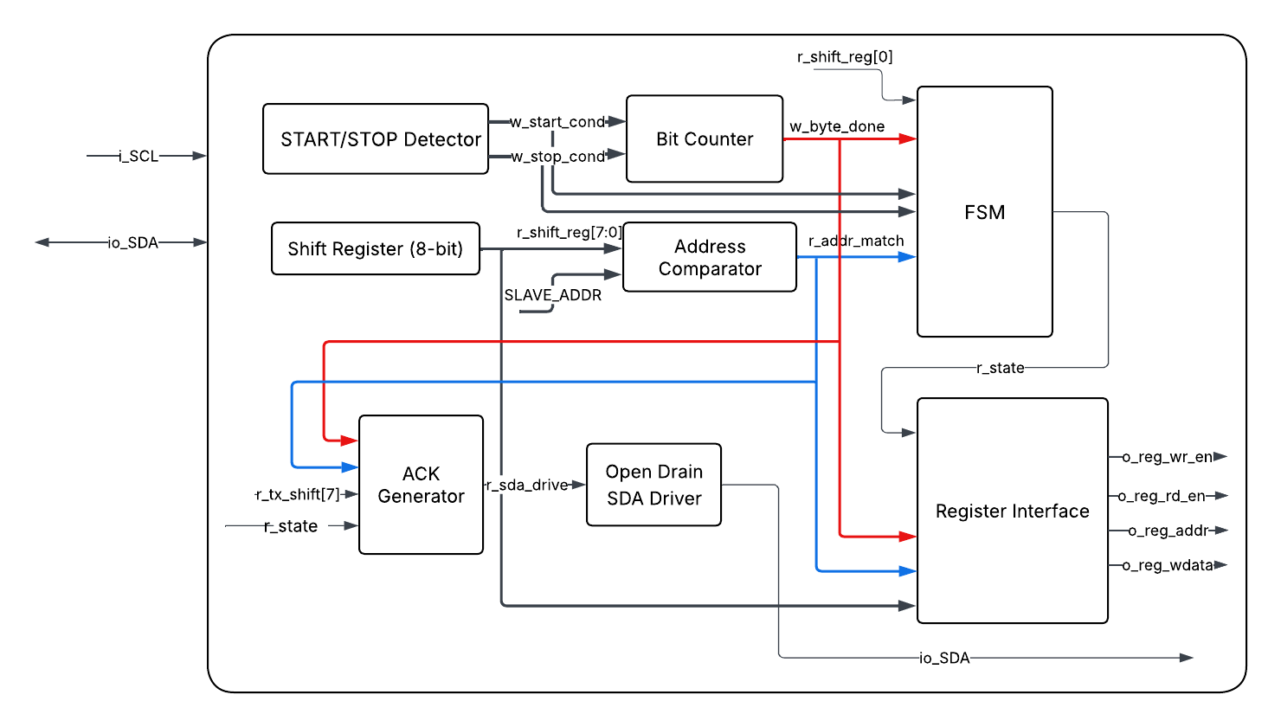
Figure 1 I2C Block Diagram
4.5 Verification Requirements
- Protocol Compliance: Verify that START, STOP, and repeated-START conditions strictly adhere to I2C timing specifications (setup and hold times relative to SCL).
- ACK/NACK Handling: * Simulate a valid sensor ACK (SDA pulled LOW on the 9th bit) and verify the FSM proceeds to the next state.
  - Simulate a NACK (SDA left HIGH) and verify the FSM safely aborts the transaction, generates a STOP condition, and asserts o_cfg_error.
- Tristate Control: Verify that o_sda_en is strictly driven LOW (High-Z) during ACK cycles and read data phases to prevent bus contention with the camera sensor.
- Clock Stretching (Optional but Recommended): Verify the controller can gracefully pause its internal FSM if the slave device holds SCL LOW to slow down the transfer.

